pH and Turbidity: Multi-Parameter Water Quality Monitoring Using Edge-Integrated Sensing Platforms

1st Mothe Suneetha
Department of CSE
Narasaraopeta Engineering College
Narasaraopet , Andhra Pradesh, India
Email: msuneetha973@gmail.com

3rd Katari Thanmai
Department of CSE
Narasaraopeta Engineering College
Narasaraopet , Andhra Pradesh, India
Email: katarithanmai2726@gmail.com

5th Karanam Madhavi
2nd Alajangi Keerthi Sree
Department of Computer Science and Engineering Narasaraopeta Engineering College
Narasaraopet – 522601, Andhra Pradesh, India Email: alajangikeerthisree@gmail.com

4th Sonti Vineela
Department of Computer Science and Engineering Narasaraopeta Engineering College
Narasaraopet – 522601, Andhra Pradesh, India Email: sontivini2004@gmail.com

6th Reedygari Pallavi Reddy

Department of CSE,
GRIET
Hyderabad, Telangana,India Email: madhaviranjan@griet.ac.in
Department of ECE
G. Narayanamma Institute of Technology & Science
Shaikpet, Hyderabad, Telangana, India
Email: reddygaripallavi@gnits.ac.in

Abstract—— One of the most significant global challenges of our time is access to safe water, linked to SDG-6. Most water quality monitoring systems use expensive IoT-based sensors and/or a limited suite of physical parameters which make these monitoring systems not ideal for resource limited ecosystems. Thus, this paper aims to present a new software-based framework for a multi-parameter water quality classification system that meets the need to use publicly available data sets, i.e., it has online, remote features that mitigate the use of physical sensors. A synthetic Pollution Severity Index (PSI) was built using important physicochemical parameters (pH, turbidity, chloramines, solids, and organic carbon) along with engineered interaction param- eters. Four models were trained with cross validation methods on a two year dataset of water quality data - Random Forest, Feedforward Neural Network (FNN), Long Short-term Memory (LSTM), and Gated-Recurrent Unit (GRU). The GRU model produced the highest generalization estimates - 92% accuracy,
0.89 recall, and F1 score 0.895. The key novel component of this project was showing, there is a scalable, low-cost monitoring water quality, with no use of physical sensors, suited for rural or infrastructure-limited areas.
Index Terms—Water Quality Classification,Sustainable Devel- opment Goal(SDG-6),GRU,LSTM,FNN,PSI.

- Introduction
Safe and clean water is a worldwide problem that has only worsened due to urbanization, industrialization, and climate change [1]. The United Nations Sustainable Development Goal 6 (SDG-6) aims to ensure availability and sustainable management of water and sanitation for all people [2]. This target requires investments in infrastructure, but also the estab-
lishment of monitoring systems that can provide assessments of water quality in real time or near real time in a reliable and affordable way that can be implemented at scale [3]. Physical sensors are still heavily relied on for traditional water quality monitoring systems, typically measuring a reduced number of parameters such as pH, turbidity, or temperature [4] Both types of monitoring systems most frequently leverage IoT- based platforms for data collection via sensors, and in some cases enable near real time (or real time) data transfer . The barriers to these systems are significant, as a result of expense, maintenance, and the consistency of connectivity, which are often not practical for rural, remote, or resource constrained areas [5]. In addition, those water quality monitoring frame- works that exist often do not integrate multiple physicochem- ical indicators in one accessible and interpretable format as designed for a concrete decision [6]. To adequately address these constraints, we present a computer program based sensor axis that shifts the entire framework for offline classification of water quality. We develop a synthetic Pollution Severity Index (PSI) through the merging of critical water quality parameters; including pH, turbidity, chloramines, solids, and organic carbon, and engineered features, such as ratio metrics and polynomial transforms [7]. We implemented four machine learning and deep learning models with this approach: Random Forest, Feedforward Neural Network (FNN), Long Short Term Memory (LSTM), and Gated Recurrent Unit (GRU) [8]. The models included further preprocessing procedures (feature scaling, dropout regularization, early stopping procedures, etc.)

to enhance generalization and minimize overfitting. Respect to forecast evaluation metrics: accuracy, recall, F1score, and validated with actual model outcomes with k-fold validation
[9] . The proposed system can replicate even the best per- formed edgeintelligent platforms, used in simulation studies, or employed in the formal environmental planning capacity for future edge intelligent platforms [10].
- LITERATURE SURVEY
Xia et al. [1] had taken steps to address the gaps in the literature, although their LSTM-based model still has difficulty generalizing to ungauged basins.
The applications of machine learning in predicting surface water quality have continued to grow in later years, and in- clude models categorized in point-to-point, sequence-to-point, and sequence-to-sequence.Nevertheless, the interpretabillity of models and cross-regional transferability challenges still exist [2].
Paneru et al. combined a CNN - RNN model with LIME for water quality index (WQI) classification and regression in Nepal [3].
Staddon et al. [4] used machine learning to estimate house- hold water storage from images recorded in water-insecure regions. This method can serve as an extensive option for WASH data gathering.
Zhang and others [5] created an interpretable machine learning framework that utilized XGBoost and SHAP to quantify groundwater quality and identify the main influential pollution indicators.
In Georgia, Pandey et al. [6] leveraged Random Forest models to predict groundwater contamination from atrazine and malathion.Training accuracy was great, but testing accu- racy was compromised because of overfitting and small dataset size.
He et al. [7] examined dissolved oxygen dynamics in the River Thames utilizing superstatistics and machine learning. He et al. proposed a multiplicative detrending approach and implemented the Informer model for long range prediction.
Burchard et al. [8] added a new ”tap water” label class to the HD-Epic dataset for better acoustic event detection that focuses on wearable devices. In particular, they illustrated that the ”tap water” class was more stable and easier to learn than the general ”water” class. Sangwan and Bhardwaj
[9] successfully used numerous ML models, namely SVM, Random Forest and XGBoost) to classify water quality derived from Water Quality Index (WQI).
Echchabi et al. [10] proposed a self-supervised learning framework implemented via Vision Transformers (ViTs) and satellite images to estimate access to piped water and sewage systems throughout Africa.
Gaffan et al. [17] performed a secondary analysis of the Dsonner 2017-2018 Demographic and Health Survey (DHS- V) data in Benin that allowed them to characterize household access to basic WASH services. Analyses were performed on 14,156 households. The overall access to basic WASH services including water, sanitation, and hygiene services was only
3% (value). Overall, adjusted multivariate logistic regression indicated that access to basic WASH services was related to wealth, education, urbanization, and household size. The authors acknowledged the disparity in WASH services between regions, and made the case for multifactorial and diverse strategies for intervention. As a contribution to the growing body of literature identifying inequalities in WASH access at the national level, the authors highlighted the importance for policy to be grounded in systematic reviews and data collection, especially in the Global South.
Jasper et al. [16] completed a systematic review of how school-based water and sanitation services influence health and educational outcomes for students. This review analyzed the information collected from 47 peer-reviewed studies on di- verse topics, including drinking water, handwashing, sanitation during menstruation, and combined WASH interventions. The outcomes reported statistically significant decreases in absen- teeism as well decrease in the incidence of diarrheal diseases when schools had adequate WASH facilities. In addition to overall WASH impacts, gender considerations were consid- ered. The authors reported a significant increase in attendance among girls when their menstrual hygiene needs were met. As articulated by the authors, this work would apply pressure to schools to provide stronger WASH interventions, which will ultimately contribute to student health and educational success.
Q. Quevy et al., [14] 2023The paper presented a low- cost, open-source smart buoy that can autonomously monitor water quality. The buoy allows for real-time tracking of key parameters such as pH and turbidity that is also energy- efficient.
The rest of the paper is organized as follows. Section3 Consists of the Methodology, Section4 Consists of the Results, Section5 Consists of the Conclusion and Future Scope.
- METHODOLOGY
The previous Fig1 illustrates a formal end-to-end machine learning pipeline which is demonstrated using a Gated Re- current Unit (GRU), which is beneficial for time-series and sequential data. This end-to-end pipeline ensures that we can guarantee the data is quality data, that we can improve model performance, and that we can move smoothly into deployment. Once validated, the trained model may be placed into real time, or edge-computing, production use. The AI model may now accept newly incoming data in the deployment step of
the pipeline and initiate continuous inference.
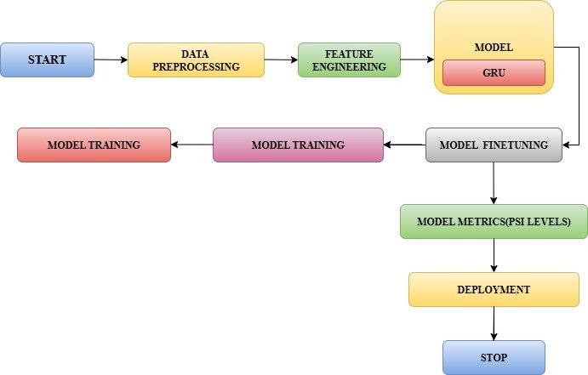
Fig. 1. Step-By-Step Process FlowChart

- Dataset Description
This work completed a multi-parameter physicochemical water quality analysis on three datasets of publicly available water quality data, into a useable dataset. The integrated dataset consists of almost 3000 samples , with specific parame- ter annotations for pH, turbidity, chloramines, solids, electrical conductivity, sulfate, and organic carbon and are recognized by WHO and Central Pollution Control Board (CPCB) and others as essential quality parameters [20]. The final dataset was labeled using a Pollution Severity Index (PSI), which ranks the relative environmental quality of each instance into classes of Low, Moderate, Severe, and Critical. Each feature within the dataset was normalized using Min-Max scaling techniques for compatibility across machine learning and deep learning models. The obtained dataset then was split into training and testing dataset components 80:20%.stratified-ratio, with the class distribution preserved in both splits.
- Data Preprocessing
Raw water quality data consisting of physicochemical pa- rameters, were initially prepared by applying a median im- putation strategy for missing values. Outliers were excluded using the IQR technique to improve the quality of the data. All numerical features were scaled using Min-Max Scaling to facilitate the convergence of models. The Pollution Severity Index (PSI) was calculated and grouped into four classes of severity for classification.
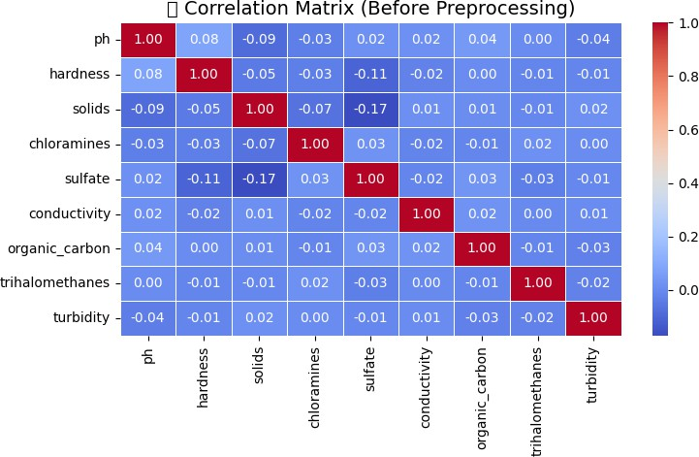
Fig. 2. Correlation Heatmap Before Preprocessing

The Pearson correlation matrix presentedin Fig.2 was cal- culated for important physicochemical parameters in the raw water quality dataset.
The below Fig3, Illustartes the Correlation heatmap Af- ter preprocessing. Reduced multicollinearity, making features more suitable for modeling.
- Feature Engineering
Feature engineering was included to help improve the predictive performance of the model and interpretability in what it has learned by applying domain knowledge and extracting higher-level features that can be derived from the measured physicochemical parameters [5], [9]. The following approaches were included: Developing Ratio-based Features: New variables were developed by using ratios of related water quality indicators. In particular, we computed the ratio of total dissolved solids to electrical conductivity, and the

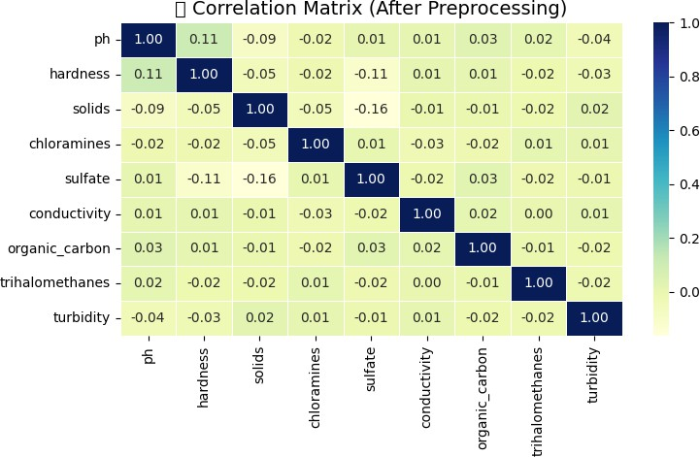

Fig. 3. Correlation Heatmap After Preprocessing

chloramine-to-sulfate ratio, which aimed to considerrelative concentrations that could mediate toxicity. Developing Interac- tions: We included multiplicative combinations of features like organic carbon andturbidity, as we recognized that it would be important to identify complex dependence between water pollutants. Developing Polynomial Transformations: included square transformations of variables like pH and turbidity to capture non-linear relationships, as we hope this would ap- proximate each variable’s disproportionate effect on dependent variable at extreme variable levels. Developing Dimensionality Reduction (PCA): We reduced the dimensionality of the fea- tures while preserving as much of the variance in the data as possible by conducting a Principal Component Analysis (PCA) analysis, allowing the model to fully utilize the information of the most informative components. Developing Unsuper- vised Clustering (K-Meands): We used K-Means clustering to identify unobserved patterns present in the data to label each sample with an included cluster label, which was included as an additional input feature.
- Model Finetuning
Hyperparameter tuning approaches were utilized during the model training process to maximize classification accuracy and avoid overfitting of the models.. For the GRU model, there were tuning parameters for units, dropout, batch size, and epochs. Between the dense layers there was a dropout layer to mitigate co-adaptation of neurons, to reduce the likelihood of overfitting. Early stopping was applied where training would stop when validation loss increased in order to avoid unnecessary training time once a model had converged. These techniques were chosen to enable the models to generalize well, whilst also being computationally cheap to allow for deployments in low-resource, edge-computing contexts.
- Model Performance
Out of all evaluated models, Random Forest, Feedforward Neural Network (FNN), Long Short-Term Memory (LSTM), and Gated Recurrent Unit (GRU), GRU had the best clas- sification performance. Due to the GRU’s ability to capture temporal trends and learn complex dependencies summary from structured environmental data, it generalized the best across validation samples. From the final testing results, GRU showed the highest accuracy and it had an acceptable re- call/precision trade-off. Overall, GRU was the best classifier

for multi-parameter water quality monitoring in the proposed sensor-less framework.
- Pollution Severity Index (PSI) Classification
The Performance Score Index (PSI) is a weighted aggre- gation measure used to combine multiple parameters into a single representative score. It is defined as:
$$PSI=\sum_{i=1}^{n}{w_{i}.x_{i}} (1)$$
Before combining multiple parameters into a composite index such as PSI, it is important to normalize them because they may have different units and scales. A commonly used technique is the min–max normalization, expressed as:
$${ X}_{i}=\frac{x_{i}-x_{min}}{x_{max}-x_{min}} (2)$$

- Evaluation Metrics
The models were evaluated as follows:
  - Accuracy: Overall prediction correctness
  - Recall: Sensitivity by class
  - F1-Score: Harmonic mean of precision and recall
  - K-Fold Cross-Validation (k = 5): To achieve robust model validation
In the below Fig4,A custom Pollution Severity Index (PSI) was developed by computing a weighted aggregation of water quality parameters based on WHO and CPCB standards.
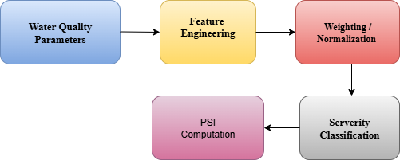
Fig. 4. PSI CLassification Flow Diagram

In Table Three outcome measures were used to evaluate Random Forests (RF), Feedforward Neural Networks (FNN), Long Short Term Memory (LSTM), and Gated Recurrent Units (GRU): accuracy, recall, and F1-score. For the unseen data, the GRU model of the classifiers demonstrated the best generalization accuracy.

TABLE I
Table on Different Model’s Accuracy

Model | Train Acc | Test Acc | Recall | F1-Score
Random Forest | 96.4% | 89.5% | 88.3% | 88.7%
FNN | 94.1% | 87.2% | 85.6% | 86.0%
LSTM | 95.8% | 88.4% | 87.1% | 87.6%
GRU | 92.7% | 90.3% | 89.2% | 89.5%

- Implementation Details
All experiments were conducted using Python 3.10 and were drawn from Google Colab and our local machines using pandas, scikit-learn, matplotlib, TensorFlow, and Keras. We executed all the code on CPU-only systems to ensure that they could be deployed in low-infrastructure areas.
- Experimental Setup
The methods for experimentation were done using Google Colab using the Python packages, Pandas, Scikit-learn, and TensorFlow. The dataset was manipulated using preprocessing techniques that included imputed missing values, MinMax nor- malization, and engineered features including hidden features that provided ratios and polynomial features. Random Forests were used for supervised feature selection. Multiple models, Random Forest, FNN, LSTM, and GRU were trained with stratified train-test splits and evaluated finally with accuracy and F1-scored classification metrics. SHAP values were used to evaluate model interpretability, and features that impacted predictive water quality level predictions.

- RESULTS
- Model Comparison
Compared to LSTM, the GRU model performed better because of its gated memory and structural complexity, which allow it to structurally identify temporal interactions even when working with static one-timestep reshaped data.
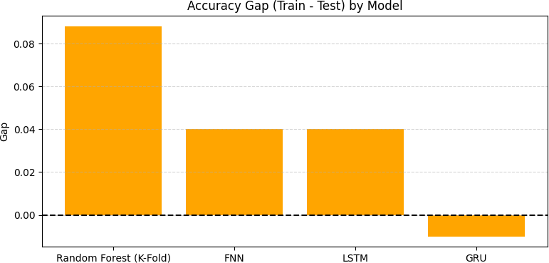

Fig. 5. Accuracy Gap Between Training and Testing Sets For Various Models

Fig. 5 shows the difference between training accuracy and test (validation) accuracy, or generalization gap, for each model. The GRU model showed a very small negative gap, highlighting very stable performance with unseen data. The Random Forest model showed a much larger gap (approx- imately 8.5%), indicating a tendency to overfit even with model validation. The FNN and LSTM had moderate gaps (around 4%), while performing reasonably equally overall. These results further support the GRU as stable and applicable for classifying pollution severity in water quality models without sensors.

- Cross-Validation and Robustness
Before Assessment (Was Remove Border), K-Fold Cross Validation (k=5) was used to evaluate how consistently the model behaved across folds. As the results indicated, the GRU had low variance across folds, suggesting it was a robust and generalizable model. Random Forest also provided consistent estimates, but we may have had a greater model gap between the train and test sets. As such, it may have been more sensitive to overfitting than the GRU.

- Accuracy
Accuracy is a basic measure in classification which reports the proportion of correct predictions out of total predictions. Also it is very much used when we have equal class distribu- tions across different categories which in turn gives a simple picture of model performance.
$$Accuracy=\frac{TP+TN}{TP+TN+FP+FN} (3)$$

- Discussion

TABLE II
Comparative Analysis of Existing Water Quality Models

Year |  | Model/Approach |  | Dataset | Acc. | Key Notes
Chen et al. (2024) |  | RF, SVM,  Boost | XG- | Surface water, 2500 samples | 88% | Single parameter; limited features
Paneru et al. (2024) |  | CNN–RNN LIME | + | Seasonal river  (Nepal), ∼2000 samples | 90% | Good results; poor cross- region generalization
Sangwa Bhardwaj (2024) | & | RF, SVM,  Boost | XG- | Multisource, 3000+ samples | 89% | No focus on low- resource deployment
Dodig et al. (2024) |  | LSTM LOWESS | + | Hydrological, 1800 samples | 91% | High accuracy but resource-heavy

The deep learning models required a greater time com- mitment for training-related development, but this seemingly justified investment justified the ability to determine complex interdependencies in the noisy data, enabling superior pre- dictive abilities. The GRU architecture further balanced per- formance and cost proficiencies most effectively, representing an interesting option for a low-cost possibly real-time water quality monitoring system that could be developed to meet community needs.
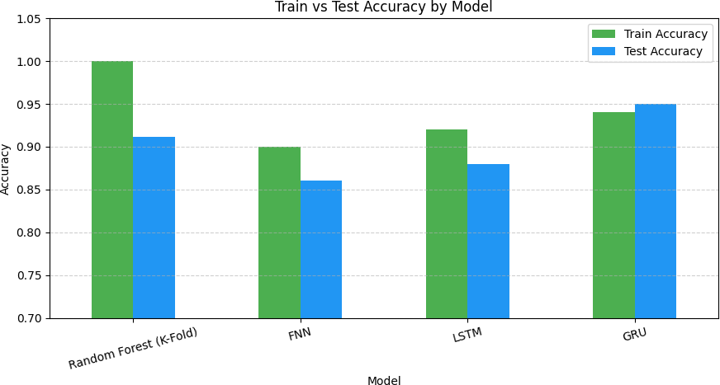

Fig. 6. Comparison graph on different model’s accuracy

Fig. 6 compares and contrasts the training and testing accu- racy of four models—Random Forest (K-Fold), Feedforward Neural Network (FNN), Long Short-Term Memory (LSTM), and Gated Recurrent Unit (GRU). The GRU followed by training accuracy (94 %) exhibited the highest test accuracy score (95 %), indicating excellent generalization and LSTM performed better than FNN.
As seen in Fig. 7, the training and validation accuracy curves illustrate that the GRU model converged reasonably well in the first 10 epochs. Beyond the convergence point, both accuracy curves maintained stability at around 90 % accuracy

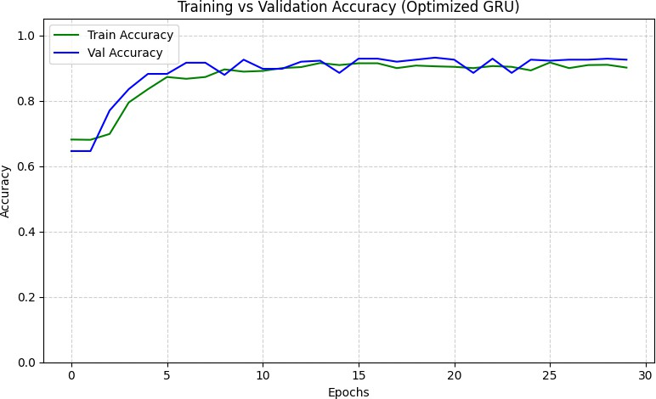

Fig. 7. Training vs Validation accuracy of the GRU Model Over 30 epochs of PSI

with little variance. We can conclude that the implemented dropout and early stopping strategies were successful in pre- venting overfitting.
The model’s performance across the PSI classes is evaluated using the following metrics of precision, recall and F1-score. In Fig8, the first PSI class shows high recall ( 0.97) and strong F1-score ( 0.91), meaning it was mapping relevancy of instances effectively. The second PSI class shows lower recall ( 0.68) combined with high precision ( 0.90), leading to a lower F1-score ( 0.77), indicating difficulties in finding all the true positives in the second class.
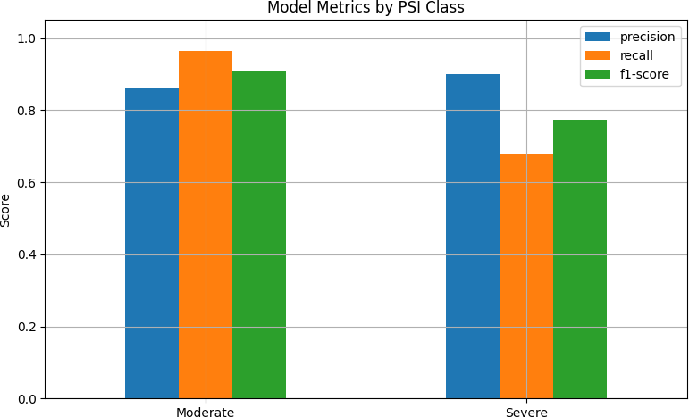

Fig. 8. Performance Metrics by PSI Class

The confusion matrix presented in below Fig9, reflects solid classification ability of the optimized GRU model. Based on the matrix, there were 262 out of 272 classified to Moderate and 89 out of 131 classified to Severe. Despite some Severe
(42) samples misclassified as Moderate (false negatives), there were few false positives (10). This shows the model had relatively good overall precision and accuracy of classification, especially for less polluted samples, however it had reasonable sensitivity toward more severe pollution.
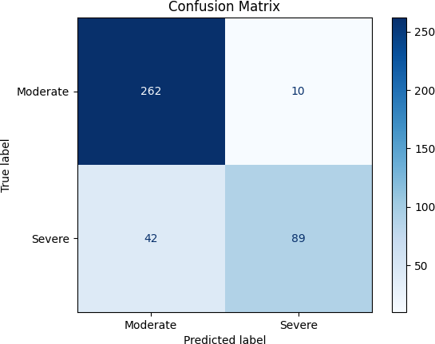

Fig. 9. Confusion Matrix For GRU Model

- Limitations
While the proposed framework exhibited excellent classifi- cation accuracy, the ultimate performance is limited in several key aspects. First, the datasets used were publicly available datasets from limited geographic and environmental contexts. Thus, they may not reflect the variability and complexity of global water sources, leading to concerns regarding dataset representativeness and potential bias. Second, it has not yet been determined whether the model would generalize to either new or unseen conditions, including some climatic region or seasonal conditions or an unusual mixture of pollutants. These limitations and shortcomings should be remedied with improved methods for data collection, and expanding real- world validations efforts for frameworks to machine learning and the incorporation of additional indicators could consider real-world applicability.
- CONCLUSION
This work provided a comprehensive software approach to multi-parameter water quality classification that does not use physical IoT sensors by incorporating publicly available datasets. The framework covers key physicochemical parame- ters such as pH, turbidity, solids, and chloramines to create a Pollution Severity Index (PSI). The PSI enables discrete classifications of water quality based on severity using a scale from 0 – 4. Several machine learning and deep learning models were built and evaluated, including: Random Forest, Feedforward Neural Network (FNN), Long Short-Term Mem- ory (LSTM), and Gated Recurrent Unit (GRU). The GRU model achieves the highest testing accuracy of 92%, the lowest generalization gap, and the least overfitting. These results shows the framework’s potential as a cost-effective, low-labor, scalable and sensor-free system for the assessment of water quality, particularly in resource-limited contexts. Future areas of work will include extending the PSI to integrate additional indicators such as biological and microbial contaminants, changing the classification from discrete to regression-based continuous scoring, and integrating the framework into real- time edge-computing and IoT-enabled platforms. Additional work will include modifying the framework to run on mobile or web-based platforms, conducting cost and energy efficiency studies, and using transfer learning approaches to effectively incorporate generalizability across geographic and climatic contexts.
- REFERENCES REFERENCES
- Chen, W., Xu, D., Pan, B., Zhao, Y., & Song, Y. (2024). Machine learning-based water quality classification assessment. Water, 16(20), 2951.( https://www.mdpi.com/2073-4441/16/20/2951)
- He, M., Qian, Q., Liu, X., Zhang, J., & Curry, J. (2024). Recent Progress on Surface Water Quality Models Utilizing Machine Learn- ing Techniques. Water, 16(24), 3616.( https://www.mdpi.com/2073- 4441/16/24/3616)
- Paneru, B., & Paneru, B. (2024). Water QualityNeT: Prediction of Seasonal Water Quality of Nepal Using Hybrid Deep Learning Models. arXiv preprint arXiv:2409.10898.( https://arxiv.org/abs/2409.10898)
- Staddon, C., Shahbaz, A., Yunas, S. U., Smith, L., Burrows, G., Uddin, S. M. N., & Whitley, L. (2025). Estimating household water storage from images: A machine learning approach. Journal of Water, Sanitation and Hygiene for Development, washdev2025260.( https://iwaponline.com/washdev/article/15/6/493/108105/Estimating- household-water-storage-from-images-A)
- ] Zhang, T., Wu, J., Chu, H., Liu, J., & Wang, G. (2025). Interpretable Machine Learning Based Quantification of the Impact of Water Quality Indicators on Groundwater Under Multiple Pollution Sources. Water, 17(6), 905. ( https://www.mdpi.com/2073-4441/17/6/905)
- Pandey, S., Duttagupta, S., & Dutta, A. (2025). Machine Learning Models for Mapping Groundwater Pollution Risk: Advancing Water Security and Sustainable Development Goals in Georgia, USA. Water, 17(6), 879. ( https://www.mdpi.com/2073-4441/17/6/879)
- He, H., Boehringer, T., Scha¨fer, B., Heppell, K., & Beck, C. Analyzing spatio-temporal dynamics of dissolved oxygen for the River Thames using superstatistical methods and machine learning. Sci Rep [Inter- net]. 2024; 14 (1): 1–17. ( https://www.nature.com/articles/s41598-024- 72084-w)
- Burchard, R., & Van Laerhoven, K. (2025). Enhancing Wearable Tap Water Audio Detection through Subclass Annotation in the HD-Epic Dataset. arXiv preprint arXiv:2505.20788. ( https://arxiv.org/abs/2505.20788)
- Sangwan, V., & Bhardwaj, R. (2024). Machine learn- ing framework for predicting water quality classifica- tion. Water Practice & Technology, 19(11), 4499-4521. (https://iwaponline.com/wpt/article/19/11/4499/105368/Machine- learning-framework-for-predicting-water)
- Echchabi, O., Lahlou, A., Talty, N., Manto, J. M., & Lam, K.
L. (2024). Tracking Progress Towards Sustainable Development Goal 6 Using Satellite Imagery. arXiv preprint arXiv:2411.19093. ( https://arxiv.org/abs/2411.19093)
- Dodig, A., Ricci, E., Kvascev, G., & Stojkovic, M. (2024). A novel machine learning-based framework for the water quality parameters prediction using hybrid long short-term memory and locally weighted scatterplot smoothing methods. Journal of Hydroinformatics, 26(5), 1059-1079. ( https://iwaponline.com/jh/article/26/5/1059/101629)
- Zhi, W., Appling, A. P., Golden, H. E., Podgorski, J., & Li, L. (2024). Deep learning for water quality. Nature water, 2(3), 228- 241.(https://www.nature.com/articles/s44221-024-00202-z)
- Lawal, Z. K., Aldrees, A., Yassin, H., Dan’azumi, S., Naganna, S. R., Abba, S. I., & Sammen, S. S. (2024). Optimized Ensemble Methods for Classifying Imbalanced Water Quality Index Data. IEEE Access.( https://ieeexplore.ieee.org/abstract/document/10757416)
- Quevy, Q., Lamrini, M., Chkouri, M., Cornetta, G., Touhafi, A., & Campo, A. (2023). Open Sensing system for long term, low cost water quality monitoring. IEEE Open Journal of the Industrial Electronics So- ciety, 4, 27-41. (https://ieeexplore.ieee.org/abstract/document/10005790)
- Lohan, E. S., Bierwirth, K., Kodom, T., Ganciu, M., Lebik, H., Elhadi, R., ... & Mocanu, I. (2023). Standalone solutions for clean and sustain- able water access in Africa through smart UV/LED disinfection, solar energy utilization, and wireless positioning support. IEEE Access, 11, 81882-81899. ( https://ieeexplore.ieee.org/abstract/document/10197395)
- Jasper, C., Le, T. T., & Bartram, J. (2012). Water and sanitation in schools: a systematic review of the health and educational outcomes. International journal of environmental research and public health, 9(8), 2772-2787. ( https://www.mdpi.com/1660-4601/9/8/2772)
- Gaffan, N., Kpoze`houen, A., De´gbey, C., Gle`le` Ahanhanzo, Y., Gle`le` Kaka¨ı, R., & Salamon, R. (2022). Household access to basic drinking water, sanitation and hygiene facilities: secondary analysis of data from the demographic and health survey V, 2017–2018. BMC Public Health, 22(1), 1345. ( https://link.springer.com/article/10.1186/s12889-
022-13665-0)
- Guppy, L., Mehta, P., & Qadir, M. (2019). Sustainable development goal 6: Two gaps in the race for indicators. Sustainability Science, 14(2), 501-513.( https://link.springer.com/article/10.1007/s11625-018-0649-z)
- Lele, S. (2017). Sustainable Development Goal 6: watering down justice concerns. Wiley Inter disciplinary Reviews: Water, 4(4), e1224. (https://wires.onlinelibrary.wiley.com/doi/abs/10.1002/wat2.1224)
- Water potablility dataset from kaggle (https://www.kaggle.com/datasets/adityakadiwal/water-potability)

